week5_0. Sample Microservices Load balancing
01_ Implementing Edge Services for Routing and Filtering
LoggingFilter.java
package com.example.edgeservice.filter;
import org.springframework.cloud.gateway.filter.GatewayFilterChain;
import org.springframework.cloud.gateway.filter.GlobalFilter;
import org.springframework.stereotype.Component;
import org.springframework.web.server.ServerWebExchange;
import reactor.core.publisher.Mono;
@Component
public class LoggingFilter implements GlobalFilter {
@Override
public Mono<Void> filter(ServerWebExchange exchange, GatewayFilterChain chain) {
System.out.println("[LOG] Request URI: " + exchange.getRequest().getURI());
return chain.filter(exchange);
}
}
EdgeServiceApplication.java
package com.example.edgeservice;
import org.springframework.boot.SpringApplication;
import org.springframework.boot.autoconfigure.SpringBootApplication;
@SpringBootApplication
public class EdgeServiceApplication {
public static void main(String[] args) {
SpringApplication.run(EdgeServiceApplication.class, args);
}
}
application.properties
spring.application.name=edge-service
server.port=8080
spring.cloud.gateway.server.webflux.routes[0].id=example_route
spring.cloud.gateway.server.webflux.routes[0].uri=http://example.org
spring.cloud.gateway.server.webflux.routes[0].predicates[0]=Path=/example/**
EdgeServiceApplicationTests.java
package com.example.edgeservice;
import org.junit.jupiter.api.Test;
import org.springframework.boot.test.context.SpringBootTest;
@SpringBootTest
class EdgeServiceApplicationTests {
@Test
void contextLoads() {
}
}
OUTPPUT
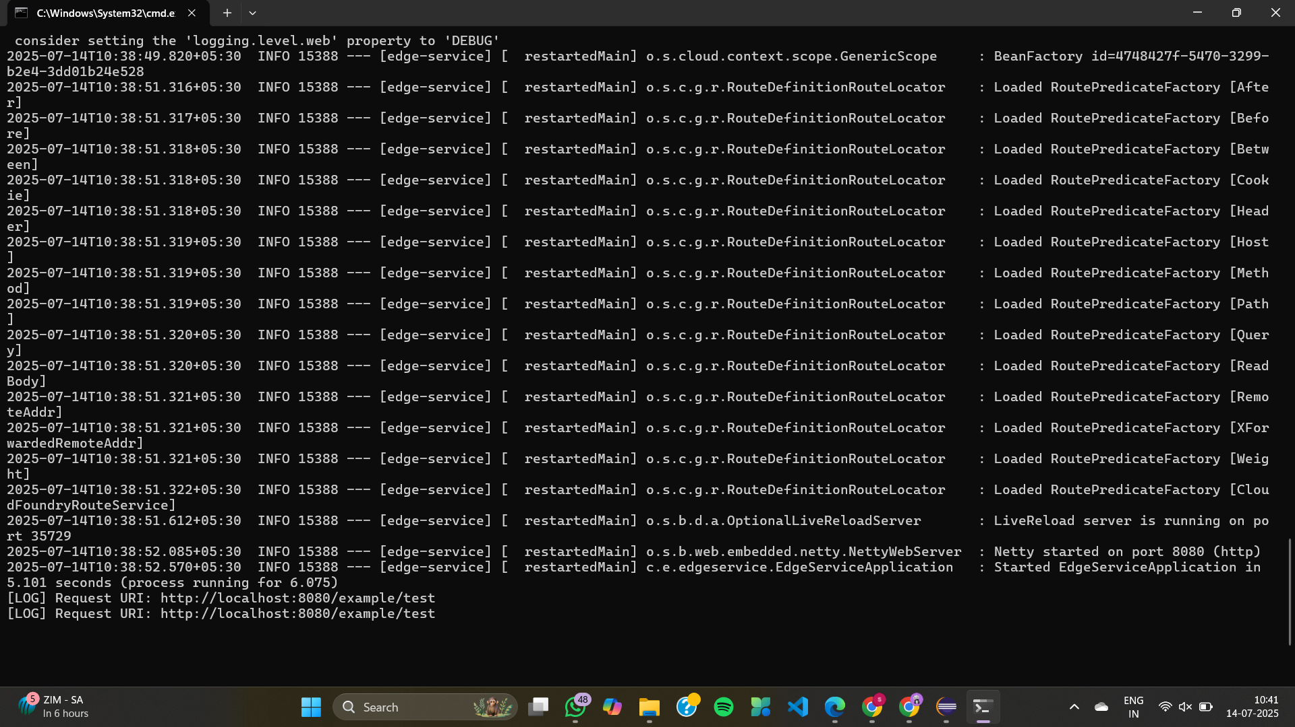
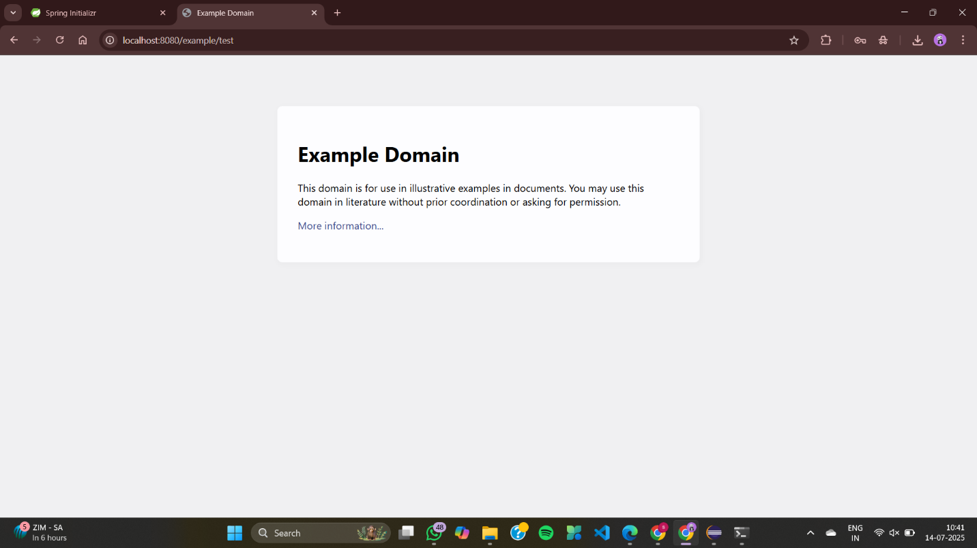

02_Load Balancing in an API Gateway
api-gateway
StaticInstanceConfiguration.java
package com.example.apigateway.config;

import java.util.List;

import org.springframework.cloud.client.DefaultServiceInstance;
import org.springframework.cloud.client.ServiceInstance;
import org.springframework.cloud.loadbalancer.core.ServiceInstanceListSupplier;
import org.springframework.context.annotation.Bean;
import org.springframework.context.annotation.Configuration;

import reactor.core.publisher.Flux;

@Configuration
public class StaticInstanceConfiguration {

@Bean
public ServiceInstanceListSupplier exampleServiceInstanceSupplier() {
return new ServiceInstanceListSupplier() {
@Override
public String getServiceId() {
return "example-service";
}

@Override
public Flux<List<ServiceInstance>> get() {
List<ServiceInstance> instances = List.of(
new DefaultServiceInstance("example-service-1", "example-service", "localhost", 8081, false),
new DefaultServiceInstance("example-service-2", "example-service", "localhost", 8082, false)
);
return Flux.just(instances);
}
};
}
}
ApiGatewayApplication.java
package com.example.apigateway;

import org.springframework.boot.SpringApplication;
import org.springframework.boot.autoconfigure.SpringBootApplication;

@SpringBootApplication
public class ApiGatewayApplication {
public static void main(String[] args) {
SpringApplication.run(ApiGatewayApplication.class, args);
}
}

application.yml
spring:
cloud:
gateway:
server:
webflux:
routes:
- id: load_balanced_route
uri: lb://example-service
predicates:
- Path=/loadbalanced/**
loadbalancer:
clients:
example-service:
instances:
- uri: http://localhost:8081
- uri: http://localhost:8082
ApiGatewayApplicationTests.java
package com.example.apigateway;

import org.junit.jupiter.api.Test;
import org.springframework.boot.test.context.SpringBootTest;

@SpringBootTest
class ApiGatewayApplicationTests {

@Test
void contextLoads() {
}

}
example-service
ExampleController.java
package com.example.exampleservice.controller;

import org.springframework.beans.factory.annotation.Value;
import org.springframework.web.bind.annotation.GetMapping;
import org.springframework.web.bind.annotation.RestController;

@RestController
public class ExampleController {

@Value("${server.port}")
private String port;

@GetMapping("/loadbalanced/message")
public String getMessage() {
return "Response from example-service on port: " + port;
}
}
ExampleServiceApplication.java
package com.example.exampleservice;

import org.springframework.boot.SpringApplication;
import org.springframework.boot.autoconfigure.SpringBootApplication;

@SpringBootApplication
public class ExampleServiceApplication {
public static void main(String[] args) {
SpringApplication.run(ExampleServiceApplication.class, args);
}
}
application-8081.properties
spring.application.name=example-service
server.port=8081
application-8082.properties
spring.application.name=example-service
server.port=8082
ExampleServiceApplicationTests.java
package com.example.example_service;

import org.junit.jupiter.api.Test;
import org.springframework.boot.test.context.SpringBootTest;

@SpringBootTest
class ExampleServiceApplicationTests {

@Test
void contextLoads() {
}

}

OUTPUT
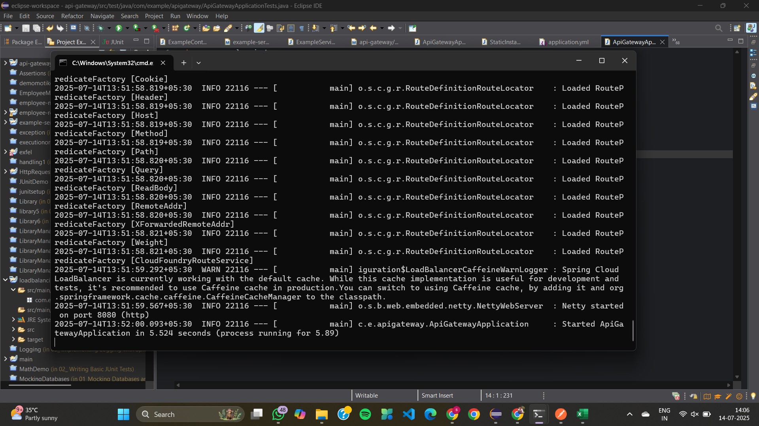
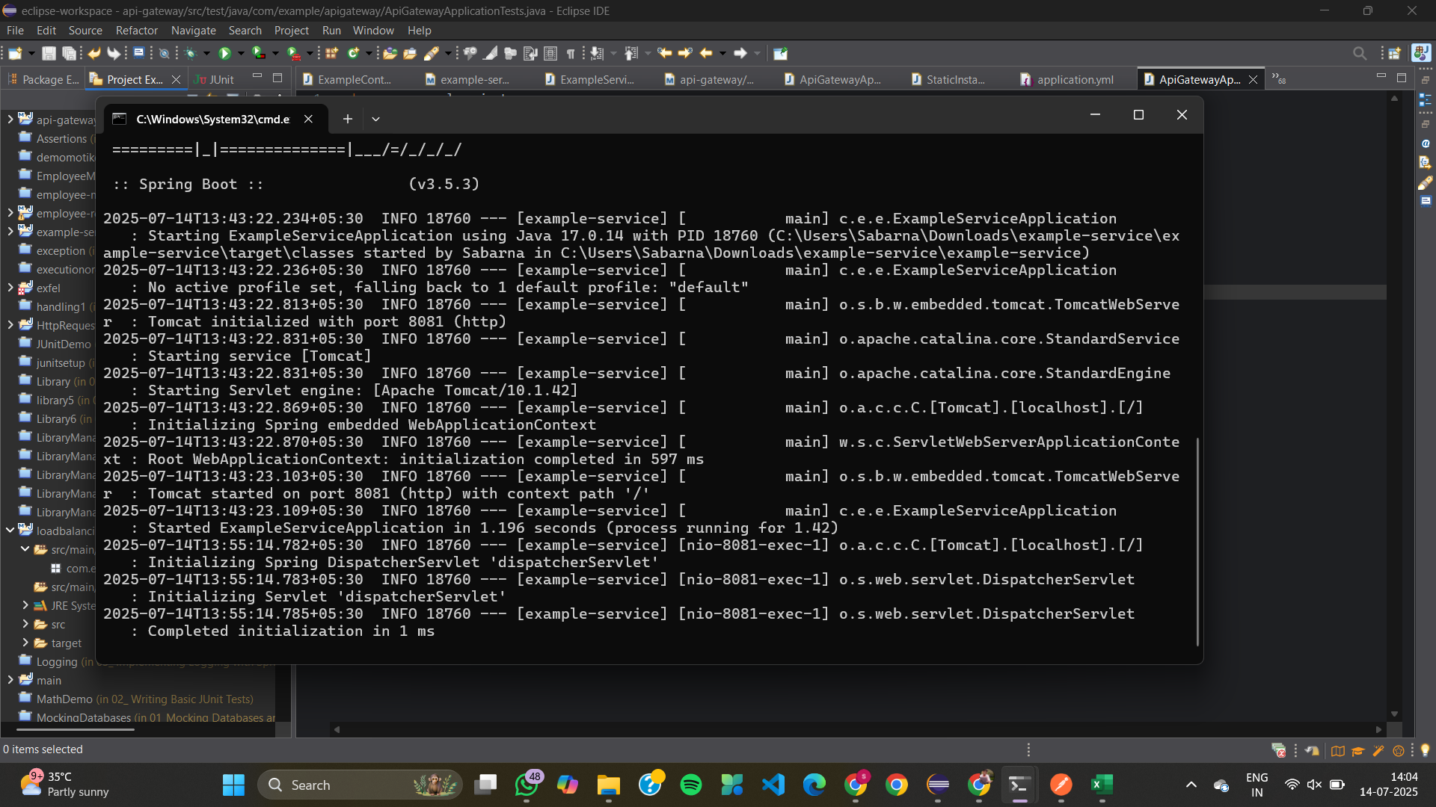

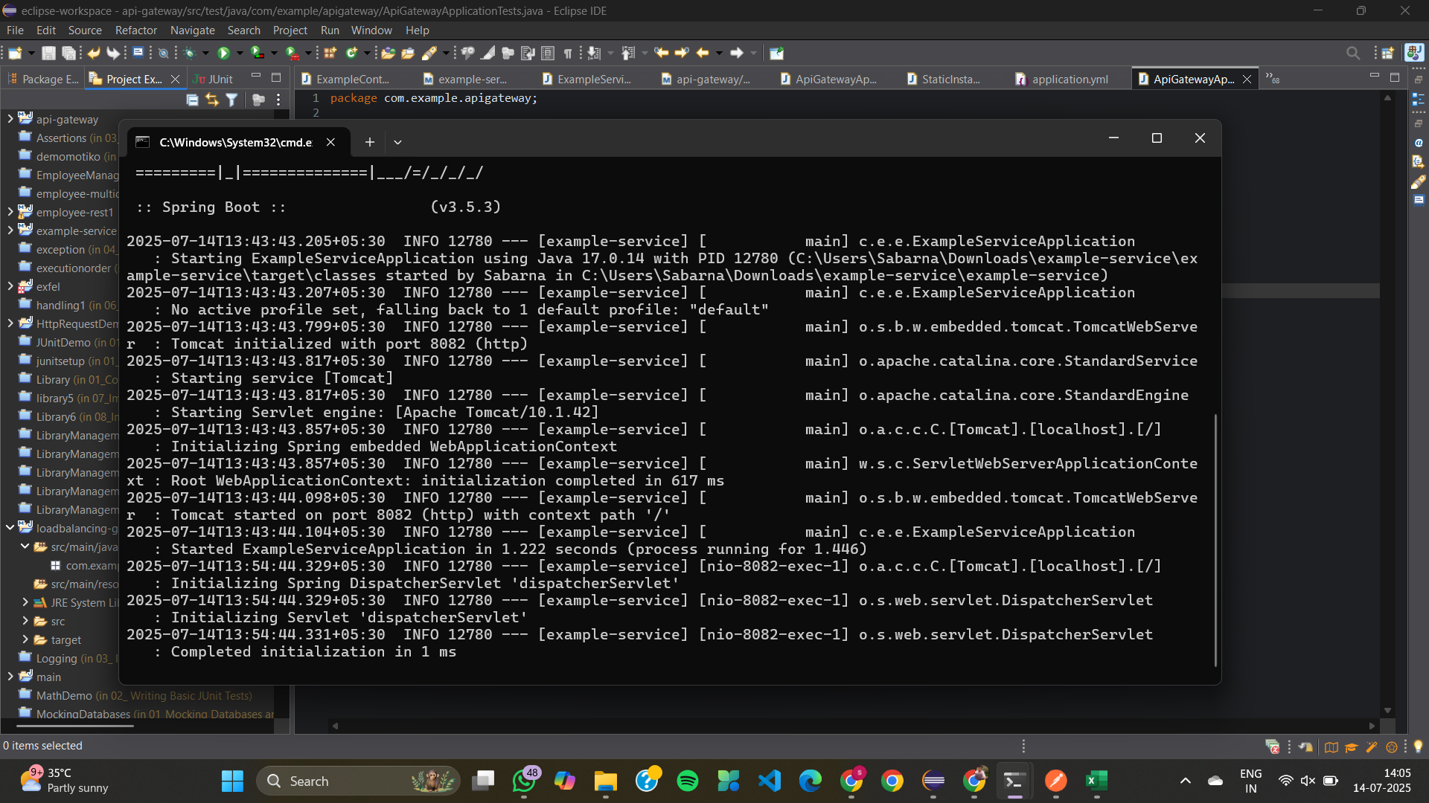

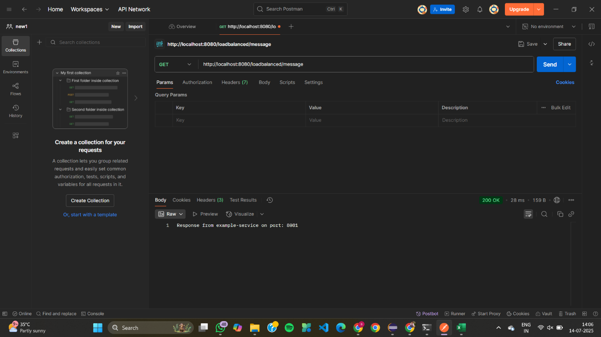

03_Resilience Patterns in an API Gateway
ImmediateFallbackFilter.java
package com.example.apigateway.config;

import org.springframework.cloud.gateway.filter.GlobalFilter;
import org.springframework.core.Ordered;
import org.springframework.http.server.reactive.ServerHttpRequest;
import org.springframework.stereotype.Component;
import org.springframework.web.server.ServerWebExchange;
import reactor.core.publisher.Mono;

@Component("ImmediateFallbackFilter")
public class ImmediateFallbackFilter implements GlobalFilter, Ordered {

@Override
public Mono<Void> filter(ServerWebExchange exchange, org.springframework.cloud.gateway.filter.GatewayFilterChain chain) {
return chain.filter(exchange)
.onErrorResume(Exception.class, ex -> {
ServerHttpRequest fallbackRequest = exchange.getRequest().mutate()
.path("/fallback/dummy")
.build();
ServerWebExchange fallbackExchange = exchange.mutate().request(fallbackRequest).build();
return fallbackExchange.getResponse().writeWith(
Mono.just(fallbackExchange.getResponse()
.bufferFactory()
.wrap("Fallback response: Dummy backend service is currently unavailable.".getBytes()))
);
});
}

@Override
public int getOrder() {
return -1; // High precedence
}
}
ApiGatewayApplication.java
package com.example.apigateway;

import org.springframework.boot.SpringApplication;
import org.springframework.boot.autoconfigure.SpringBootApplication;

@SpringBootApplication
public class ApiGatewayApplication {
public static void main(String[] args) {
SpringApplication.run(ApiGatewayApplication.class, args);
}
}
application.properties
server.port=8080

spring.cloud.gateway.routes[0].id=dummy-route
spring.cloud.gateway.routes[0].uri=http://localhost:8081
spring.cloud.gateway.routes[0].predicates[0]=Path=/dummy/test
spring.cloud.gateway.routes[0].filters[0]=CircuitBreaker=name=exampleCircuitBreaker,fallbackUri=forward:/fallback/dummy
resilience4j.circuitbreaker.instances.exampleCircuitBreaker.slidingWindowSize=2
resilience4j.circuitbreaker.instances.exampleCircuitBreaker.failureRateThreshold=10
resilience4j.circuitbreaker.instances.exampleCircuitBreaker.registerHealthIndicator=true
resilience4j.circuitbreaker.instances.exampleCircuitBreaker.waitDurationInOpenState=5s

management.endpoints.web.exposure.include=*
logging.level.org.springframework.cloud.gateway=DEBUG
logging.level.reactor.netty=DEBUG

OUTPUT
